**EATING WITH A SPOON** 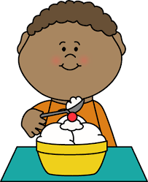

1. Pick up spoon from table, bowl or plate

2. Scoop food from bowl or plate

3. Hold spoon level enough to carry food to mouth

4. Put food in mouth

5. Close lips to remove food from spoon

6. Return spoon to bowl or plate

7. Chew, as needed

8. Swallow food

(Repeat the steps until satisfied or until the bowl or plate is empty of food)

(PIRS Team: Barbara Berger, Susan Monfet, Janice Torres, Simone Smith)

**Teaching kids to use a knife and fork**

If your child is right-handed then the knife will go in the right hand. For children who are left-handed (like the child below), the knife goes in the left hand. Once you have the cutlery sorted, all you need to do is follow these steps:

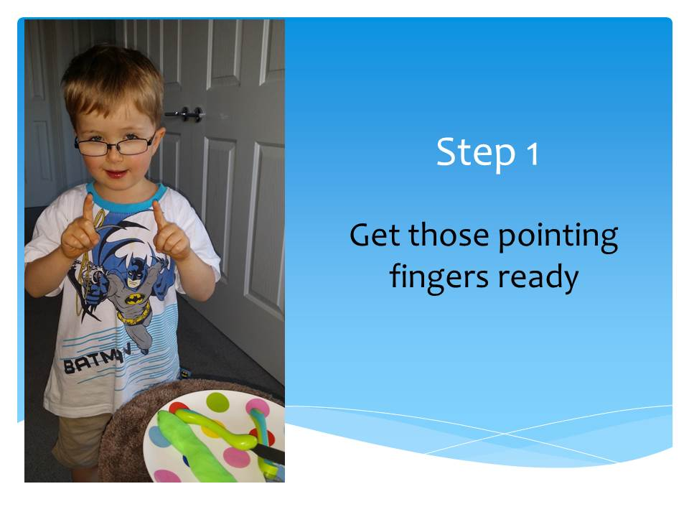

[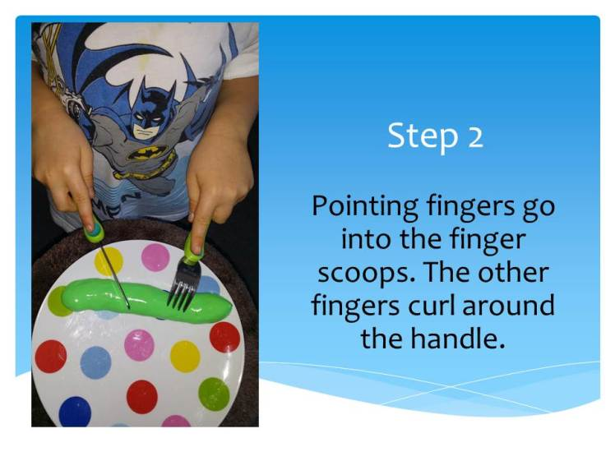](https://steppingstonestherapy.files.wordpress.com/2015/09/slide3.jpg)

[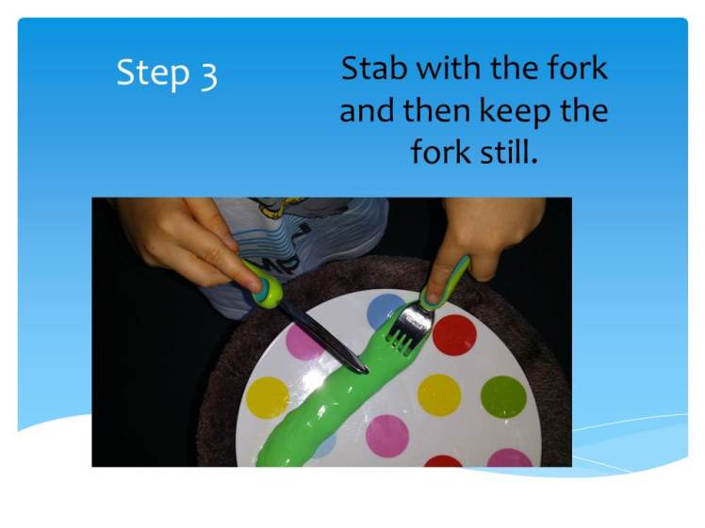](https://steppingstonestherapy.files.wordpress.com/2015/09/slide4.jpg)

[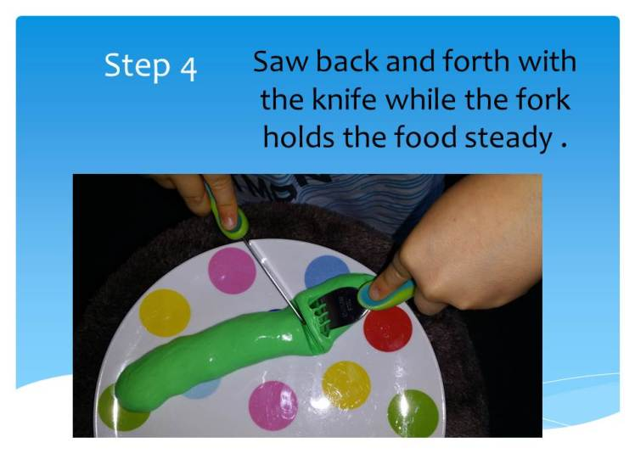](https://steppingstonestherapy.files.wordpress.com/2015/09/slide5.jpg)

A fun way to practice cutlery skills is with Play-doh. Get your child to roll out some ‘sausages’ and then away they go. This can be a much less intimidating way to practice. Then try using real food at dinner time. Use child-friendly cutlery😊 *Source: Stepping Stones-Occupational Therapy for Children*